**SMART TRAFFIC SYSTEM USING IoT**

|  |  |
| --- | --- |
| **Tejas Gupta**  **TE CMPN A**  **Roll No.: 29** | **Deven Mistry**  **TE CMPN A**  **Roll No.: 55** |

**Introduction:**

Nowadays, controlling the traffic becomes major issue because of rapid increase in automobiles and also because of large time delays between traffic lights. So, in order to rectify this problem, we will go for density based traffic system. It is very important to get live and accurate updates of the traffic at any time. The existing systems give the count of mobile station on the road but not the count of vehicles on the road. The proposed system gives the count of vehicles on the road.

**WORKING:**

* The Arduino is connected to two IR sensors
* The IR sensor continuously fires an IR beam, when the beam is intercepted by a vehicle then IR is reflected back to the sensor
* It senses a that vehicle has passed by and sends this data to the Arduino
* The IR sensor at the entrance when sends the data, the counter is incremented meaning that the car currently on the road
* When the car leaves the other end, the counter is decremented
* The counter gives the LIVE data of the vehicles on the road
* This can be used to find the traffic density of the road taking in consideration the capacity of the road
* **Traffic Density can be calculated by**

**Traffic % = $\frac{Number Vehicles on the Road}{Capacity of the Road}$ x 100**

* **Range Indicators:**

|  |  |
| --- | --- |
| **Traffic %** | **Status** |
| **Greater than 80** | **High Traffic** |
| **Greater than 50** | **Moderate Traffic** |
| **Greater than 20** | **Low Traffic** |
| **Lesser than 20** | **No Traffic** |

* **Block diagram of the proposed prototype**

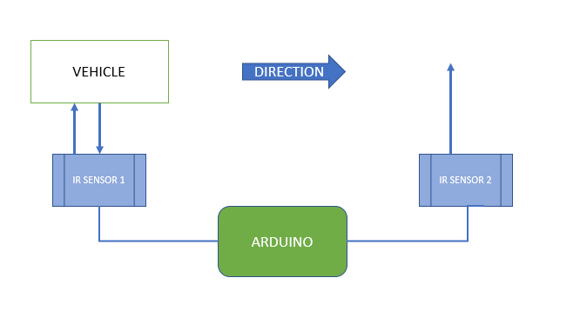

**Components Used:**

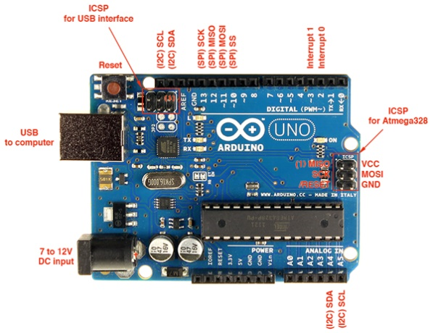

**Arduino Uno**

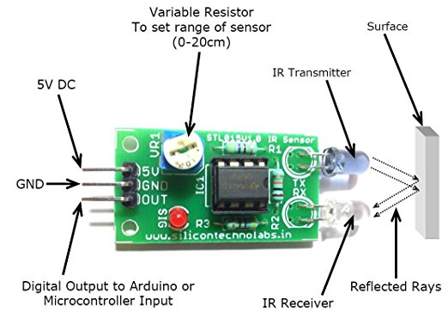

**IR Sensors**

**CODE OF ARDUINO**

int pushButton = 2;

int dec = 4;

float counter = 0;

boolean prevState = false;

boolean curState = false;

boolean prevState1 = false;

boolean curState1 = false;

void setup() {

Serial.begin(9600);

pinMode(pushButton, INPUT);

pinMode(dec, INPUT);

}

void loop() {

prevState = curState;

curState = digitalRead(pushButton);

prevState1 = curState1;

curState1 = digitalRead(dec);

if (!curState && prevState) {

counter++;

if((counter/10)>=0.8)

Serial.println("HIGH TRAFFIC");

else if ((counter/10)<0.8 && (counter/10)>=0.5)

Serial.println("MODERATE TRAFFIC");

else if ((counter/10)>=0.2 && (counter/10)<0.5)

Serial.println("LOW TRAFFIC");

else if((counter/10)<0.2)

Serial.println("NO TRAFFIC");

}

if (!curState1 && prevState1) {

counter--;

counter = constrain(counter, 0, 1000);

if((counter/10)>=0.8)

Serial.println("HIGH TRAFFIC");

else if ((counter/10)>=0.5 && (counter/10)<0.8)

Serial.println("MODERATE TRAFFIC");

else if ((counter/10)>=0.2 && (counter/10)<0.5)

Serial.println("LOW TRAFFIC");

else if((counter/10)<0.2)

Serial.println("NO TRAFFIC");

}

delay(100);

}